[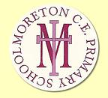](http://www.moretonceprimaryschool.co.uk/)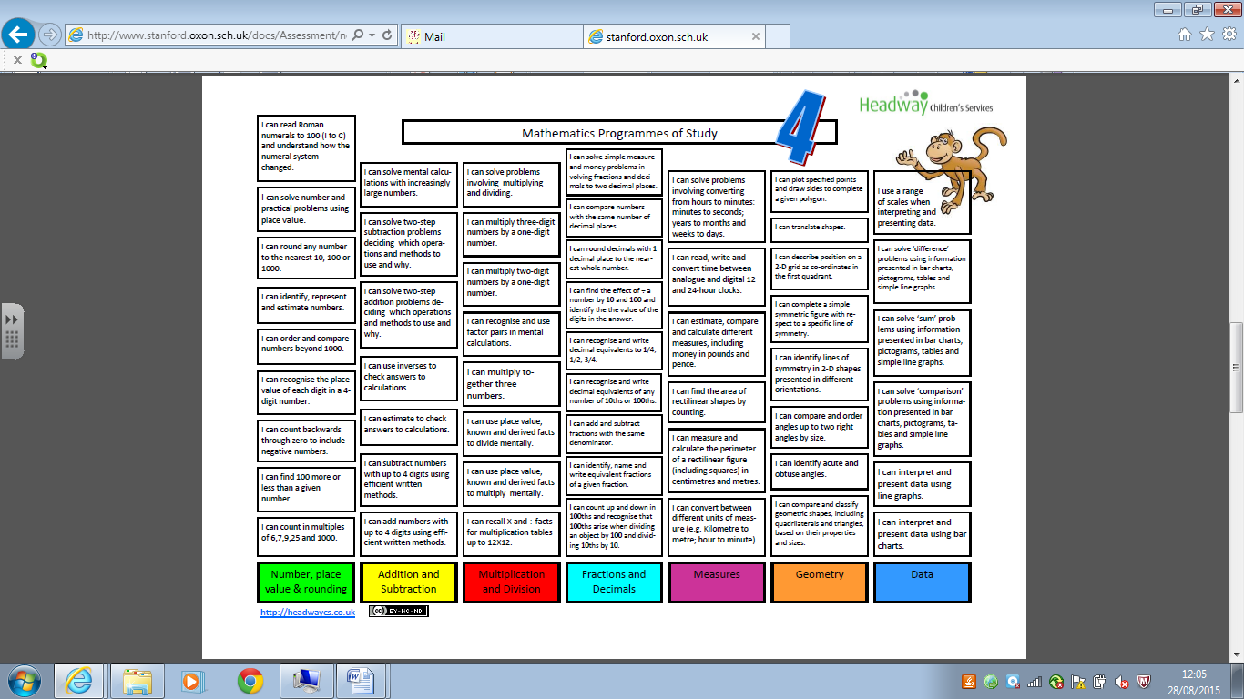

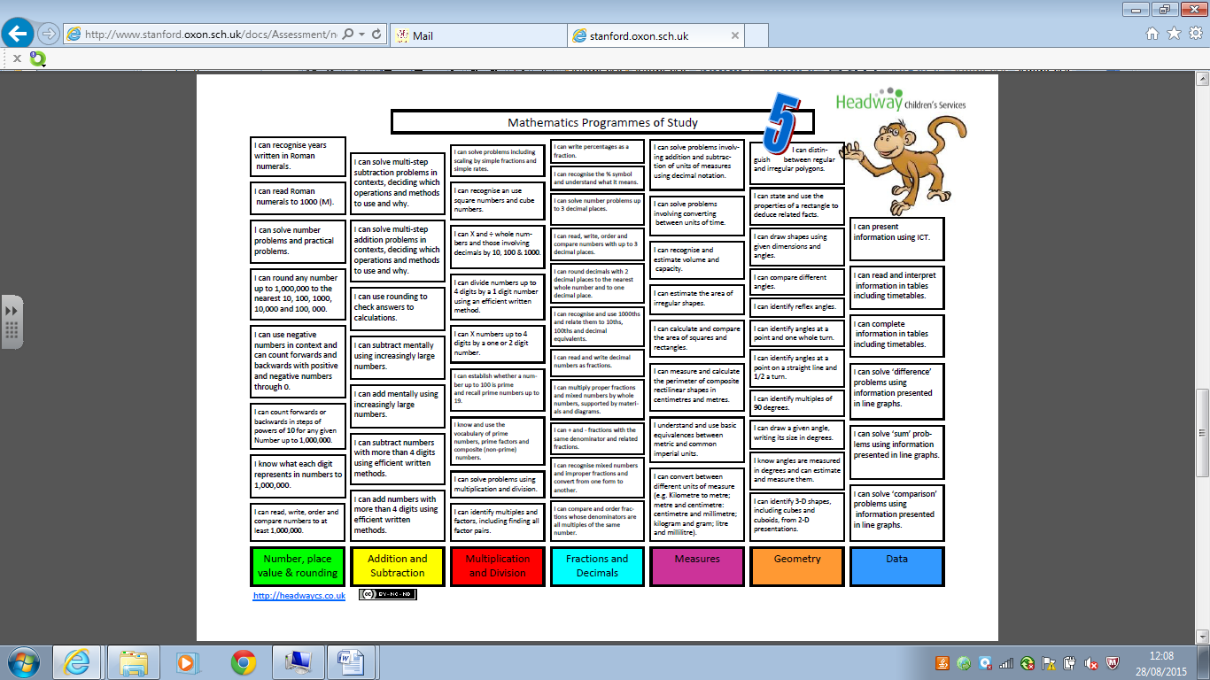[](http://www.moretonceprimaryschool.co.uk/)

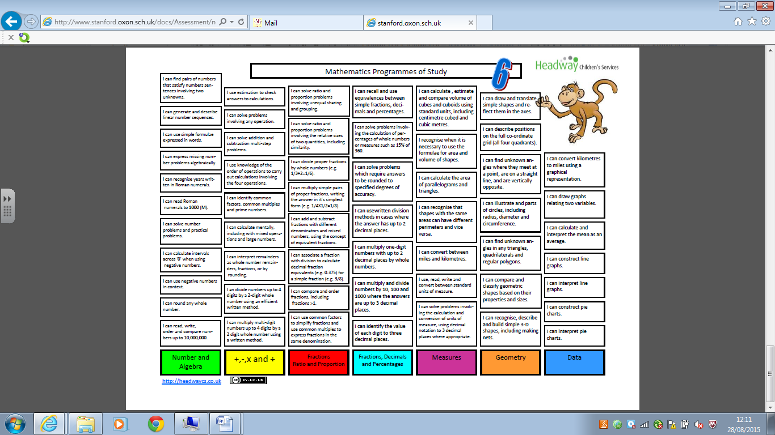[](http://www.moretonceprimaryschool.co.uk/)